
Data Mining Project
Sleep Disorder Analysis

Team Members:

- Preethi Sri B - 23MIS0470
- Yuva Krithikka S - 23MIS0437
- Madhumitha B - 23MSO360

Abstract:
This project aims to analyze and classify datasets using various supervised learning methods to study model performance and statistical behavior. A part of the reduced dataset-subset_reduced_dataset.xlsx with the dimensionalities of attributes A to F-was used for preprocessing, scaling of features, and classification. It uses major classifiers-Decision Tree, SVM, Naive Bayes, and KNN-to effectively predict target classes. Each model performance was evaluated by confusion matrices, statistical measures, and ROC curve analysis. This paper aims to consider the most accurate and reliable classifier while visualizing the efficiency in combined metrics and ROC plots for the chosen models. This work demonstrates how different classifiers behave on the same dataset and highlights the importance of preprocessing and model evaluation for successful predictive modeling in data mining.

Preprocessing:

In order to classify the dataset, a series of preprocessing steps were required. The data was imported from an Excel file and studied to be complete and consistent. Label encoding was applied to any categorical attributes so that they were numerical for the algorithms in machine learning. Features A-F columns selected were standardized by StandardScaler; hence, the scale for all attributes was such that each contributed equally to the model with zero mean and unit variance. The dataset was then split into training and test subsets in a 70:30 ratio, hence allowing reliable model evaluations. This preprocessing pipeline thereby cleaned and scaled the data for effective classification and performance comparison.

Classifiers :

Four different supervised learning algorithms were implemented: Decision Tree, SVM, Naive Bayes, and KNN. In the Decision Tree classifier, the recursive splitting of data with respect to information gain gives a hierarchical structure for classification. The SVM classifier separates data by an optimal hyperplane such that the margin between classes is highest. The Naive Bayes classifier applies Bayes' theorem with an assumption of feature independence to offer a computationally efficient model for probabilistic classification. KNN predicts the target class of an example based on the majority vote of its k closest neighbors in the feature space. All the classifiers were trained with the same set of training data and tested with the same test data to measure the fair performance comparison among them.

Evaluation:

Performance metrics for each classifier included Accuracy, Precision, Recall (Sensitivity), Specificity, F-Measure, and Error Rate. Additionally, True Positives (TP), True Negatives (TN), False Positives (FP), and False Negatives (FN) were calculated for every model. Confusion matrices were generated for each classifier to plot a visual representation of the performance of classification, including a summary confusion matrix afterwards that combined all the models' results. An ROC curve showing the models' discriminative power was plotted, which highlighted visually the trade-off between sensitivity and specificity. In this way, full comprehension of the strengths and weaknesses of each classifier was obtained, enabling the determination of which model best fit the characteristics of the dataset.

Template:
Phase 1 –
- Pre-Processing
      - Data Cleaning
      - Data Integration
      - Data Transformation
      - Date Reduction

- Statistical Measures
Phase 2 –
- Classifiers
- KNN
- Naïve Bayes
- Decision Tree
Phase 3 –
- Accuracy
- Precision
- Error Rate
- Sensitivity
- Specificity
- F-Measure

Pre-Processing:
--- Data Cleaning ---
Code:
import pandas as pd
file_path = r"C:\Users\User\OneDrive\Documents\DataMining Proj\sleep_disorder_dataset.xlsx"
df = pd.read_excel(file_path, sheet_name="Sheet1")
df.drop_duplicates(inplace=True)
df.dropna(subset=["Patient_ID"], inplace=True)
df["Age"].fillna(df["Age"].median(), inplace=True)
df["AHI_Score"].fillna(df["AHI_Score"].median(), inplace=True)
df["SaO2_Level"].fillna(df["SaO2_Level"].median(), inplace=True)
df["Gender"].fillna(df["Gender"].mode()[0], inplace=True)
df["Sleep_Disorder_Type"].fillna(df["Sleep_Disorder_Type"].mode()[0], inplace=True)
df["Gender"] = df["Gender"].str.strip().str.title() # Male/Female
df["Sleep_Disorder_Type"] = df["Sleep_Disorder_Type"].str.strip().str.title()
df["Diagnosis_Confirmed"] = df["Diagnosis_Confirmed"].astype(int)
if "OCR_Extracted_Text" in df.columns:
df.drop(columns=["OCR_Extracted_Text"], inplace=True)
cleaned_file = r"C:\Users\User\OneDrive\Documents\DM\cleaned_sleep_disorder_dataset.xlsx"
df.to_excel(cleaned_file, index=False)
print("Data cleaning complete! Cleaned file saved as:", cleaned_file)

--- Data Integration ---
Code:
import pandas as pd
sleep_file = r"C:\Users\User\OneDrive\Documents\DataMining Proj\cleaned_sleep_disorder_dataset.xlsx"
lifestyle_file = r"C:\Users\User\OneDrive\Documents\DataMining Proj\patient_lifestyle_data.xlsx"
sleep_df = pd.read_excel(sleep_file)
lifestyle_df = pd.read_excel(lifestyle_file)
sleep_df["Patient_ID"] = sleep_df["Patient_ID"].astype(str).str.strip()
lifestyle_df["Patient_ID"] = lifestyle_df["Patient_ID"].astype(str).str.strip()
print("Unique IDs in sleep dataset:", len(sleep_df["Patient_ID"].unique()))
print("Unique IDs in lifestyle dataset:", len(lifestyle_df["Patient_ID"].unique()))
common_ids = set(sleep_df["Patient_ID"]).intersection(set(lifestyle_df["Patient_ID"]))
print("Number of common Patient_IDs:", len(common_ids))
integrated_df = pd.merge(sleep_df, lifestyle_df, on="Patient_ID", how="inner")
integrated_file = r"C:\Users\User\OneDrive\Documents\DataMining Proj\integrated_dataset.xlsx"
integrated_df.to_excel(integrated_file, index=False)
print("Integration complete! Rows after merge:", len(integrated_df);
--- Data Transformation ---
Code:
import pandas as pd
from sklearn.preprocessing import MinMaxScaler, LabelEncoder
integrated_file = r"C:\Users\User\OneDrive\Documents\DataMining Proj\integrated_dataset.xlsx"
df = pd.read_excel(integrated_file)
scaler = MinMaxScaler()
numeric_cols = ["Age", "AHI_Score", "SaO2_Level"]
df[numeric_cols] = scaler.fit_transform(df[numeric_cols])
label_enc = LabelEncoder()
categorical_cols = ["Gender", "Sleep_Disorder_Type", "Smoking_Habit", "Alcohol_Consumption", "Caffeine_Intake", "Work_Shift"]
for col in categorical_cols:
df[col] = label_enc.fit_transform(df[col].astype(str))
df["Age_Group"] = pd.cut(
df["Age"],
bins=[0, 0.3, 0.6, 1.0],
labels=["Young", "Middle", "Old"]
)
transformed_file = r"C:\Users\User\OneDrive\Documents\DataMining Proj\transformed_dataset.xlsx"
df.to_excel(transformed_file, index=False)
print("Data transformation complete! Transformed file saved as:", transformed_file)

--- Data Reduction ---
Code:
import pandas as pd
from sklearn.preprocessing import MinMaxScaler, LabelEncoder
integrated_file = r"C:\Users\User\OneDrive\Documents\DataMining Proj\integrated_dataset.xlsx"
df = pd.read_excel(integrated_file)
scaler = MinMaxScaler()
numeric_cols = ["Age", "AHI_Score", "SaO2_Level"]
df[numeric_cols] = scaler.fit_transform(df[numeric_cols])
label_enc = LabelEncoder()
categorical_cols = ["Gender", "Sleep_Disorder_Type", "Smoking_Habit", "Alcohol_Consumption", "Caffeine_Intake", "Work_Shift"]
for col in categorical_cols:
df[col] = label_enc.fit_transform(df[col].astype(str))
df["Age_Group"] = pd.cut(
df["Age"],
bins=[0, 0.3, 0.6, 1.0],
labels=["Young", "Middle", "Old"]
)
transformed_file = r"C:\Users\User\OneDrive\Documents\DataMining Proj\transformed_dataset.xlsx"
df.to_excel(transformed_file, index=False)
print("Data transformation complete! Transformed file saved as:", transformed_file)

Statistical Measures:
Code:
import pandas as pd
import matplotlib.pyplot as plt
from scipy.stats import chi2_contingency
from sklearn.metrics.pairwise import cosine_similarity
import numpy as np
import scipy.stats as stats
from scipy.spatial import distance
from scipy.spatial.distance import pdist, squareform
import gower
from sklearn.preprocessing import LabelEncoder
file_path = r"C:\Users\User\OneDrive\Documents\DataMining Proj\subset_reduced_dataset.xlsx"
df = pd.read_excel(file_path)
df_AF = df.iloc[:, 0:6]
df_selected = df.iloc[:, 0:6]
print("----- Central Tendency Measures -----")
print("\nMean values:")
print(df.mean(numeric_only=True))
print("\nMedian values:")
print(df.median(numeric_only=True))
print("\nMode values:")
print(df.mode(numeric_only=True).iloc[0])
print("----- Range, Quartiles & IQR -----")
print("\nRange (Max - Min):")
range_values = df.max(numeric_only=True) - df.min(numeric_only=True)
print(range_values)
print("\nQuartiles (Q1, Q2, Q3):")
Q1 = df.quantile(0.25, numeric_only=True)
Q2 = df.quantile(0.50, numeric_only=True)
Q3 = df.quantile(0.75, numeric_only=True)
print("Q1:\n", Q1)
print("Q2 (Median):\n", Q2)
print("Q3:\n", Q3)
print("\nInterquartile Range (IQR):")
IQR = Q3 - Q1
print(IQR)
print("----- Five Number Summary -----")
five_num_summary = pd.DataFrame({
"Minimum": df.min(numeric_only=True),
"Q1 (25%)": df.quantile(0.25, numeric_only=True),
"Median (Q2)": df.median(numeric_only=True),
"Q3 (75%)": df.quantile(0.75, numeric_only=True),
"Maximum": df.max(numeric_only=True)
})
print(five_num_summary)
numeric_cols = df.select_dtypes(include=['number']).columns
print("----- Outlier Detection using IQR -----")
outliers_dict = {}
for col in numeric_cols:
Q1 = df[col].quantile(0.25)
Q3 = df[col].quantile(0.75)
IQR = Q3 - Q1
lower_bound = Q1 - 1.5 * IQR
upper_bound = Q3 + 1.5 * IQR
outliers = df[(df[col] < lower_bound) | (df[col] > upper_bound)][col]
outliers_dict[col] = outliers.values
print(f"\n{col}:")
print(f"Lower Bound = {lower_bound}, Upper Bound = {upper_bound}")
print(f"Outliers: {outliers.values if len(outliers) > 0 else 'None'}")
plt.figure(figsize=(12, 6))
df[numeric_cols].boxplot()
plt.title("Boxplots with Outliers (shown as dots)")
plt.xticks(rotation=45)
plt.show()
print("----- Variance -----")
print(df_AF.var(numeric_only=True))
print("\n----- Standard Deviation -----")
print(df_AF.std(numeric_only=True))
print("----- Covariance Matrix -----")
print(df_AF.cov())
print("\n----- Correlation Matrix -----")
print(df_AF.corr())
contingency_table = pd.crosstab(df.iloc[:,0], df.iloc[:,1])
chi2, p, dof, expected = chi2_contingency(contingency_table)
print("Chi-Square Test Results:")
print("Chi2 Value:", chi2)
print("p-value:", p)
print("Degrees of Freedom:", dof)
for column in df_selected.columns:
data = df_selected[column].dropna()
quantiles = np.linspace(0, 1, len(data))
sorted_data = np.sort(data)
plt.figure(figsize=(8, 5))
plt.plot(quantiles, sorted_data, 'o', markersize=3)
plt.title(f"Quantile Plot for {column}")
plt.xlabel("Quantiles (0 to 1)")
plt.ylabel(column)
plt.grid(True)
plt.show()
for col in df_AF.columns:
stats.probplot(df_AF[col], dist="norm", plot=plt)
plt.title(f"Q–Q Plot for {col}")
plt.show()
df_AF.hist(figsize=(12, 8), bins=15)
plt.suptitle("Histograms of A–F Columns")
plt.show()
pd.plotting.scatter_matrix(df_AF, figsize=(12, 8), diagonal='hist')
plt.suptitle("Scatter Matrix Plot")
plt.show()
print("----- Pearson Correlation -----")
print(df_AF.corr(method='pearson'))
print("\n----- Cosine Similarity -----")
cos_sim = cosine_similarity(df_AF.T)
cosine_df = pd.DataFrame(cos_sim, index=df_AF.columns, columns=df_AF.columns)
print(cosine_df)
row1 = df_AF.iloc[0]
row2 = df_AF.iloc[1]
minkowski_dist = distance.minkowski(row1, row2, p=3)
print("Minkowski Distance (p=3) between Row1 & Row2:", minkowski_dist)
euclidean = distance.euclidean(row1, row2)
manhattan = distance.cityblock(row1, row2)
supremum = distance.chebyshev(row1, row2)
print("Euclidean Distance:", euclidean)
print("Manhattan Distance:", manhattan)
print("Supremum (Chebyshev) Distance:", supremum)
euclidean_matrix = squareform(pdist(df_AF, metric='euclidean'))
print("Euclidean Dissimilarity Matrix:\n", euclidean_matrix)
manhattan_matrix = squareform(pdist(df_AF, metric='cityblock'))
print("\nManhattan Dissimilarity Matrix:\n", manhattan_matrix)
supremum_matrix = squareform(pdist(df_AF, metric='chebyshev'))
print("\nSupremum (Chebyshev) Dissimilarity Matrix:\n", supremum_matrix)
df_nominal = df_selected.astype(str).apply(LabelEncoder().fit_transform)
def simple_matching(u, v):
return np.sum(u != v) / len(u)
nominal_dist = squareform(pdist(df_nominal.values, metric=simple_matching))
print("\nNominal/Categorical (Simple Matching):")
print(pd.DataFrame(nominal_dist).round(2))
df_binary = df_selected.applymap(lambda v: 1 if v > df_selected.median().median() else 0)
binary_dist = squareform(pdist(df_binary.values, metric="jaccard"))
print("\nBinary (Jaccard Distance):")
print(pd.DataFrame(binary_dist).round(2))
df_ordinal = df_selected.rank(method="average") / df_selected.rank(method="average").max()
ordinal_dist = squareform(pdist(df_ordinal.values, metric="euclidean"))
print("\nOrdinal (Euclidean on Ranks):")
print(pd.DataFrame(ordinal_dist).round(2))
gower_dist = gower.gower_matrix(df_selected)
gower_dist = np.round(gower_dist, 2)
print("\n---Mixed Attributes---")
print(pd.DataFrame(gower_dist))

Output:
----- Central Tendency Measures -----

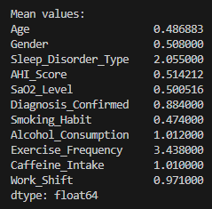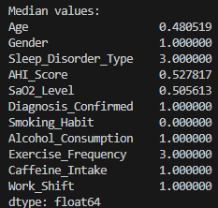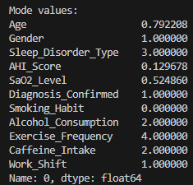

----- Range, Quartiles & IQR -----

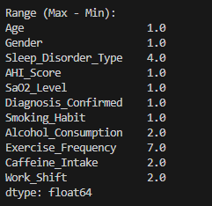
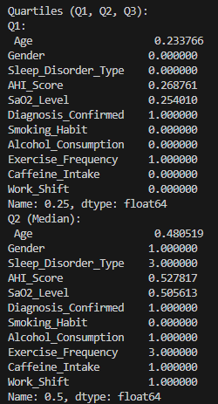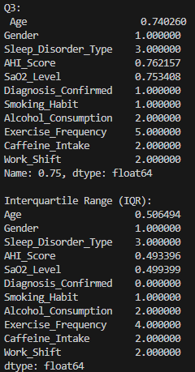

----- Five Number Summary -----

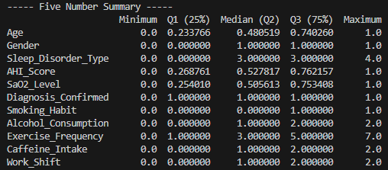
----- Outlier Detection using IQR -----

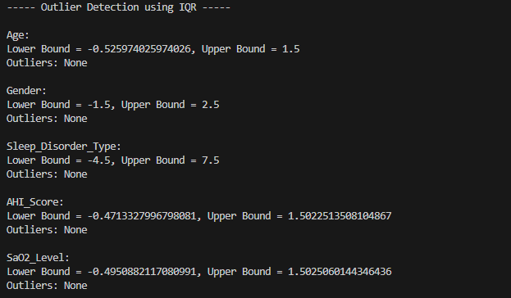
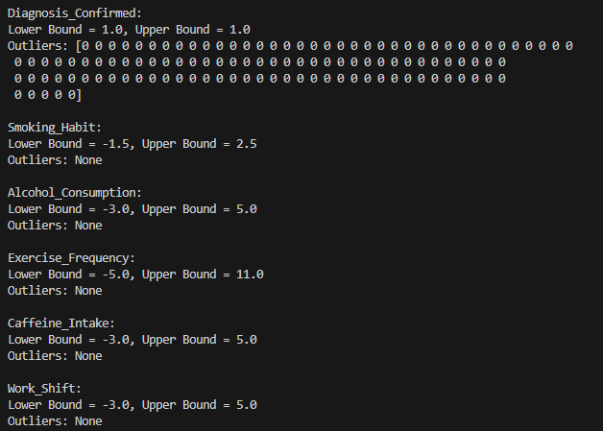

----BoxPlot----
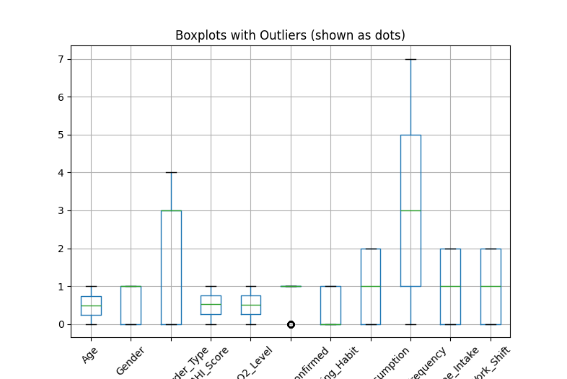
----- Variance -----
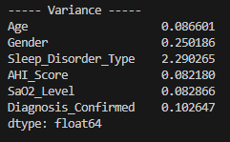

----- Standard Deviation -----
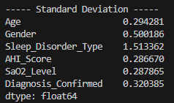

----- Covariance Matrix -----
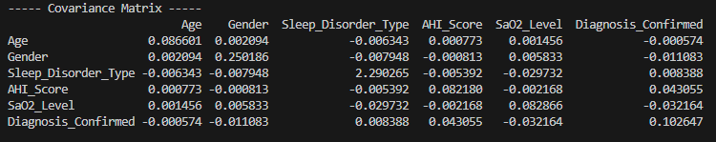

----- Correlation Matrix -----
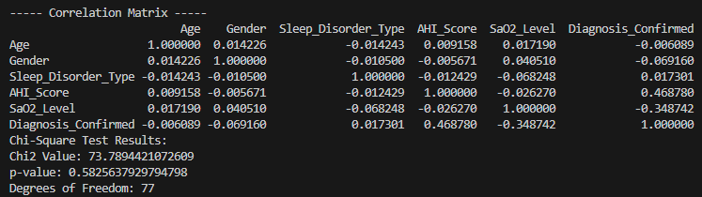

---Quantile Plot---
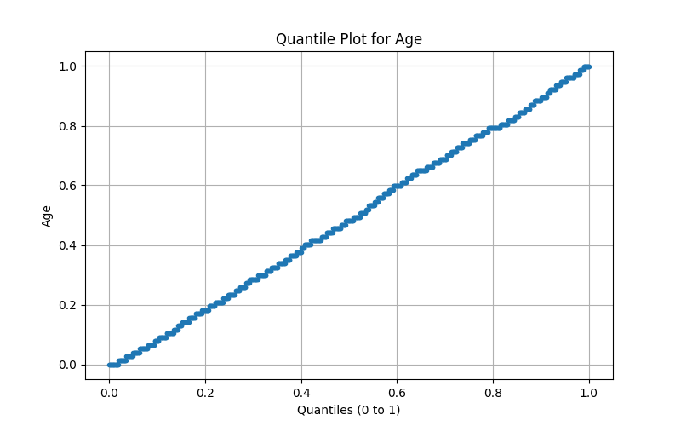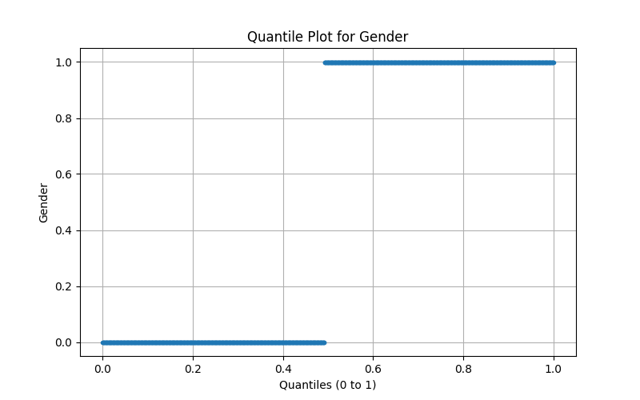
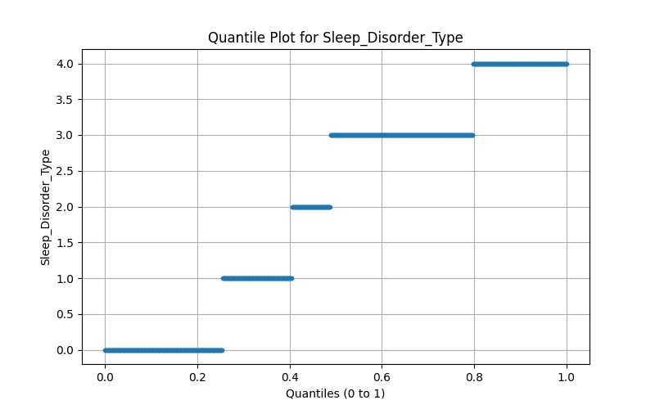
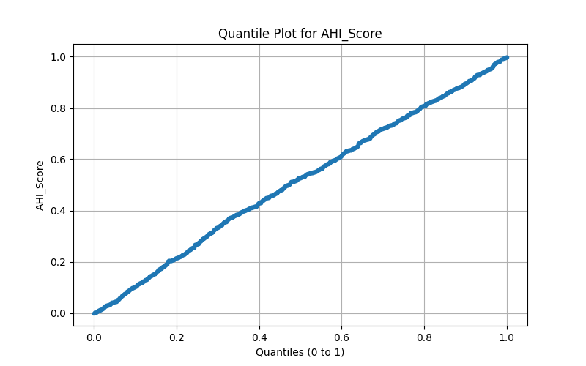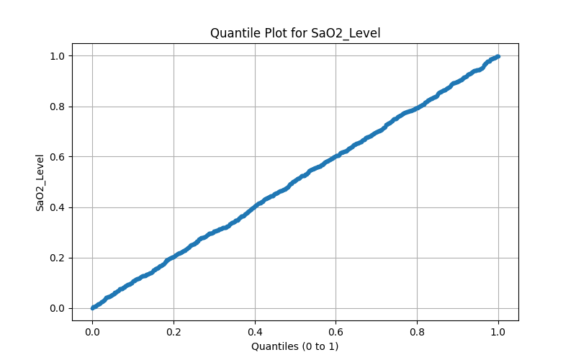
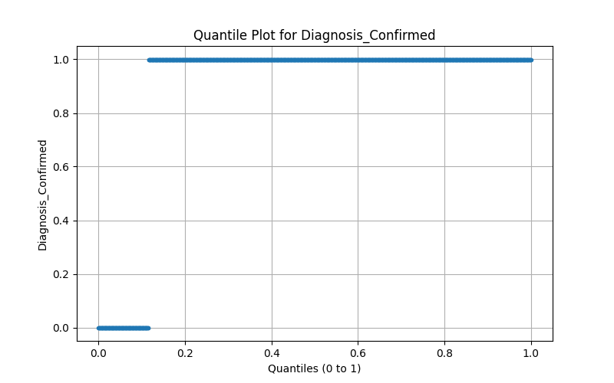

---Q-Q Plot---
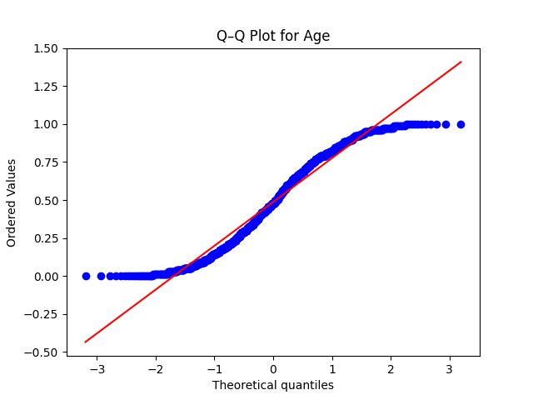
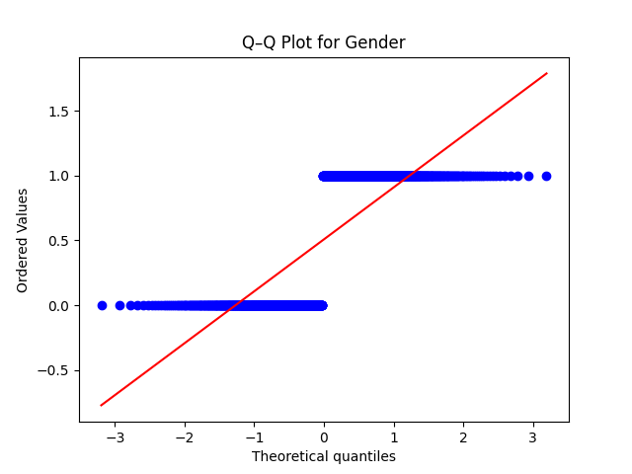
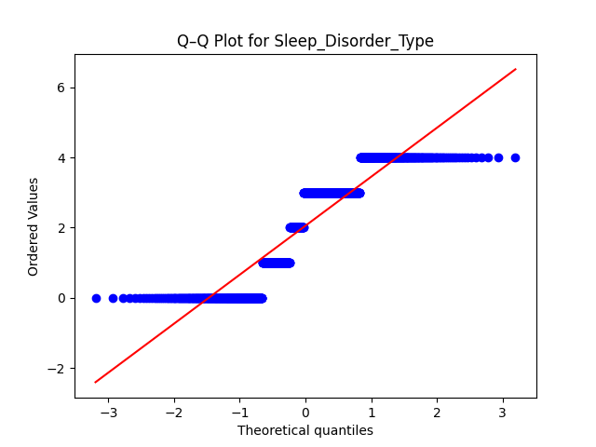
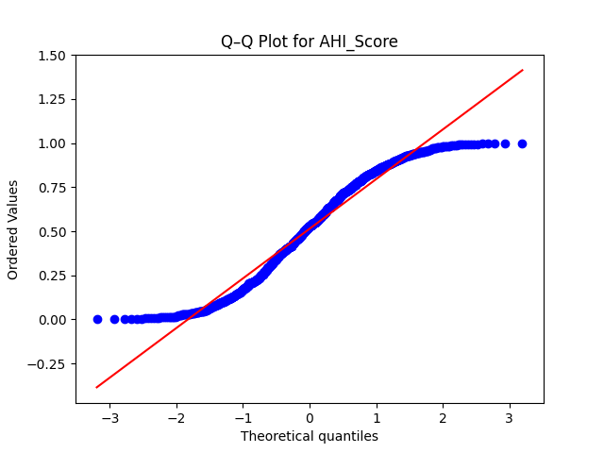
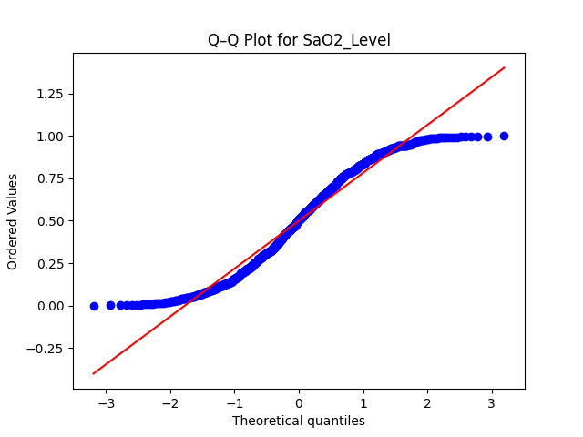
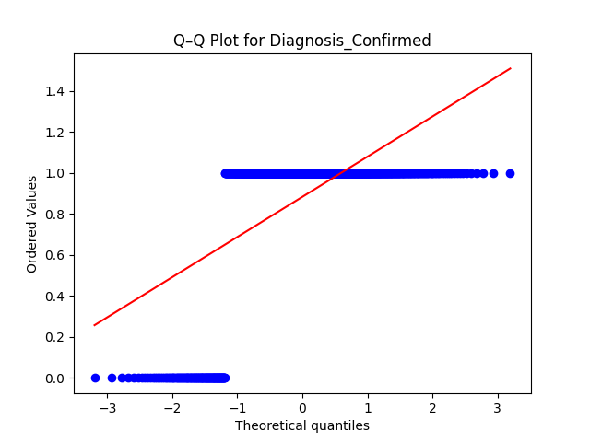

---Histogram---

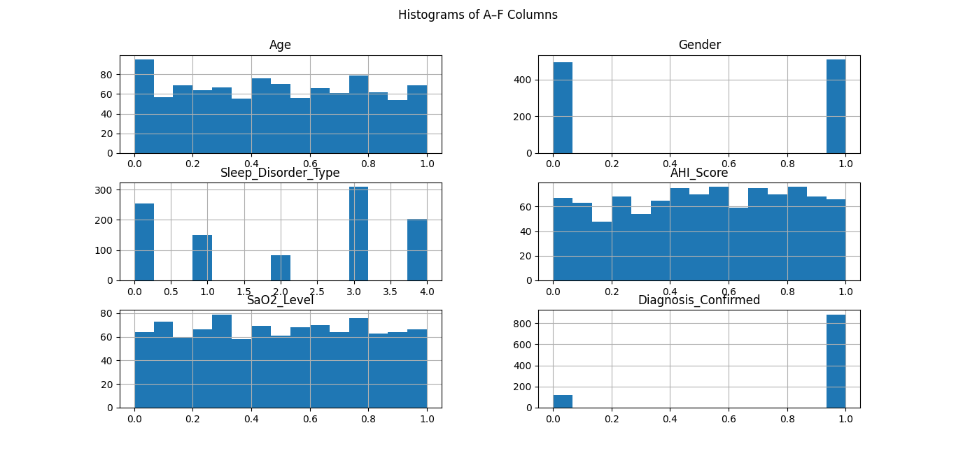
---Scatter Plot---
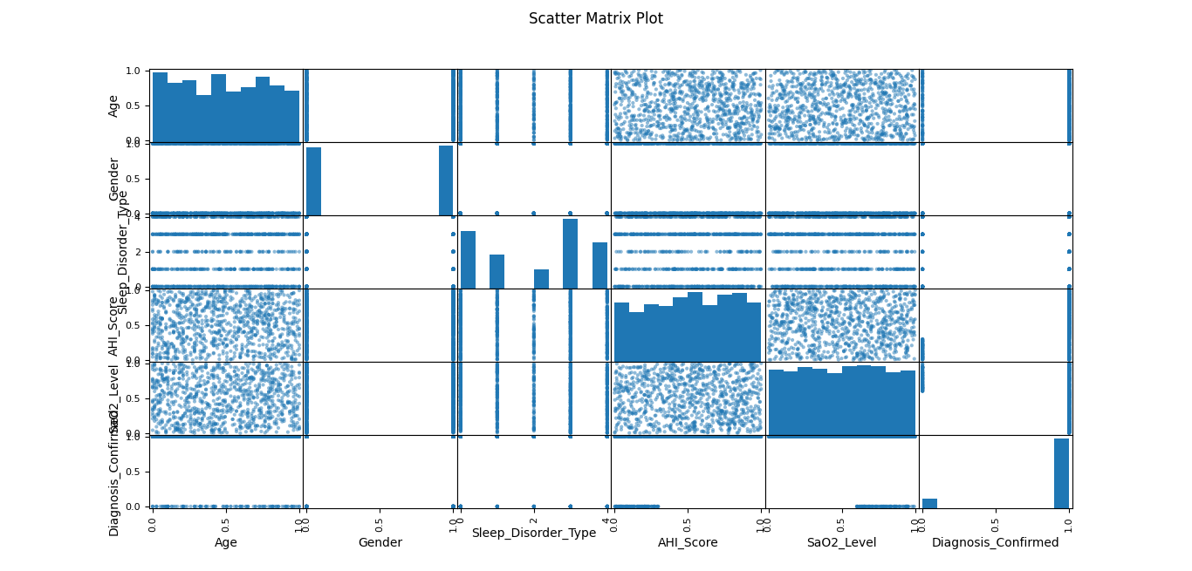
----- Pearson Correlation -----
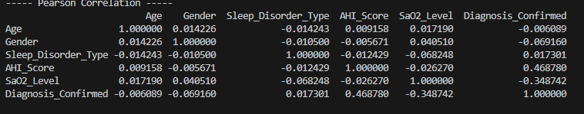
----- Cosine Similarity -----
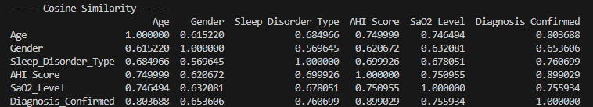
---Minkowshki Distance---
---Disimilarity Measures---

---Dissimilarity Matrix---
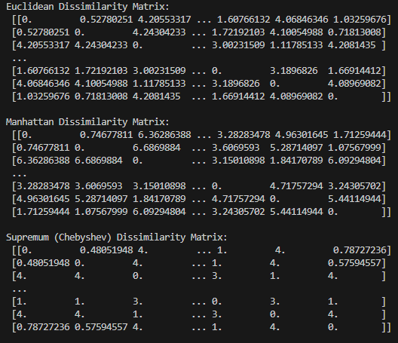
---SIMMILARITY AND DISSIMILARITY FOR(ORDINAL,NOMINAL,BINARY)---
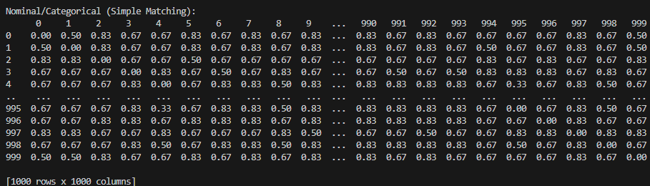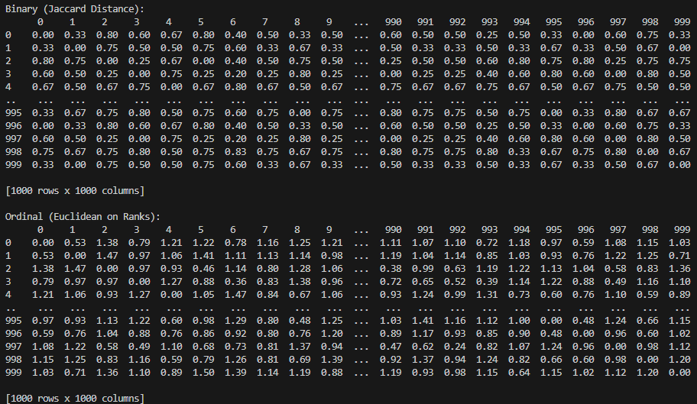

---Mixed Attributes---
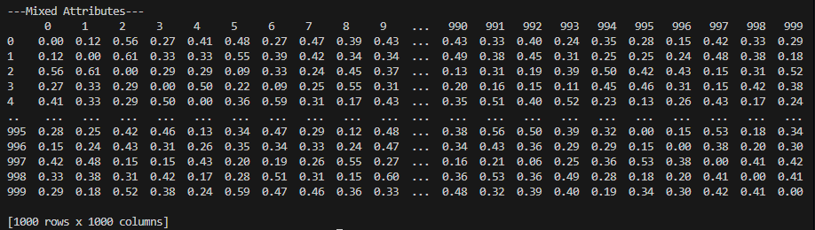

Classifiers and Evaluation:
Code:
import pandas as pd
import numpy as np
from sklearn.model_selection import train_test_split
from sklearn.preprocessing import LabelEncoder, StandardScaler
from sklearn.metrics import (
confusion_matrix, accuracy_score, precision_score,
recall_score, f1_score, roc_curve, auc
)
from sklearn.tree import DecisionTreeClassifier
from sklearn.naive_bayes import GaussianNB
from sklearn.neighbors import KNeighborsClassifier
import matplotlib.pyplot as plt
import seaborn as sns
data = pd.read_excel("subset_reduced_dataset.xlsx", usecols="A:F")
print(" Dataset Loaded Successfully!\n")
le = LabelEncoder()
for column in data.columns:
if data[column].dtype == "object":
data[column] = le.fit_transform(data[column])
X = data.iloc[:, :-1]
y = data.iloc[:, -1]
scaler = StandardScaler()
X_scaled = scaler.fit_transform(X)
X_train, X_test, y_train, y_test = train_test_split(X_scaled, y, test_size=0.3, random_state=42)
classifiers = {
"Decision Tree": DecisionTreeClassifier(random_state=42),
"Naive Bayes": GaussianNB(),
"KNN": KNeighborsClassifier(n_neighbors=5)
}
results = {}
combined_cm = np.zeros((2, 2), dtype=int)
for name, clf in classifiers.items():
clf.fit(X_train, y_train)
y_pred = clf.predict(X_test)
cm = confusion_matrix(y_test, y_pred)
if cm.shape == (2, 2):
tn, fp, fn, tp = cm.ravel()
else:
tn = fp = fn = tp = np.nan
accuracy = accuracy_score(y_test, y_pred)
precision = precision_score(y_test, y_pred, average="macro", zero_division=0)
recall = recall_score(y_test, y_pred, average="macro", zero_division=0)
f_measure = f1_score(y_test, y_pred, average="macro")
error_rate = 1 - accuracy
specificity = tn / (tn + fp) if not np.isnan(tn) else np.nan
sensitivity = tp / (tp + fn) if not np.isnan(tp) else np.nan
results[name] = {
"TP": tp, "TN": tn, "FP": fp, "FN": fn,
"Accuracy": accuracy,
"Precision": precision,
"Error Rate": error_rate,
"Sensitivity": sensitivity,
"Specificity": specificity,
"F-Measure": f_measure,
"Confusion Matrix": cm,
}
print(f"\n===== {name} =====")
print(f"TP: {tp}, TN: {tn}, FP: {fp}, FN: {fn}")
print(f"Accuracy: {accuracy:.4f}")
print(f"Precision: {precision:.4f}")
print(f"Error Rate: {error_rate:.4f}")
print(f"Sensitivity (Recall): {sensitivity}")
print(f"Specificity: {specificity}")
print(f"F-Measure: {f_measure:.4f}")
print("Confusion Matrix:\n", cm)
plt.figure(figsize=(4, 3))
sns.heatmap(cm, annot=True, fmt='d', cmap='Blues')
plt.title(f"Confusion Matrix - {name}")
plt.xlabel("Predicted")
plt.ylabel("Actual")
plt.tight_layout()
plt.show()
if cm.shape == (2, 2):
combined_cm += cm
print("\n===== Combined Confusion Matrix =====")
print(combined_cm)
plt.figure(figsize=(5, 4))
sns.heatmap(combined_cm, annot=True, fmt='d', cmap='Purples')
plt.title("Combined Confusion Matrix (Decision Tree + Naive Bayes + KNN)")
plt.xlabel("Predicted")
plt.ylabel("Actual")
plt.tight_layout()
plt.show()
if len(np.unique(y)) == 2:
plt.figure(figsize=(8, 6))
for name, clf in classifiers.items():
if hasattr(clf, "predict_proba"):
y_score = clf.predict_proba(X_test)[:, 1]
fpr, tpr, _ = roc_curve(y_test, y_score)
roc_auc = auc(fpr, tpr)
plt.plot(fpr, tpr, lw=2, label=f"{name} (AUC = {roc_auc:.2f})")
else:
print(f"{name} does not support predict_proba for ROC curve.")
plt.plot([0, 1], [0, 1], "k--", lw=1)
plt.xlabel("False Positive Rate")
plt.ylabel("True Positive Rate")
plt.title("Combined ROC Curve (Decision Tree, Naive Bayes, KNN)")
plt.legend(loc="lower right")
plt.grid(True)
plt.tight_layout()
plt.show()
else:
print("\n ROC Curve skipped — dataset must be binary for combined ROC plotting.")

# ----------------------------- SUMMARY TABLE -----------------------------
summary_df = pd.DataFrame.from_dict(results, orient="index")
summary_df = summary_df.drop(columns=["Confusion Matrix"])
summary_df = summary_df.round(4)

print("\n===== CLASSIFIER PERFORMANCE SUMMARY =====")
print(summary_df)

# Save summary to Excel
summary_df.to_excel("classifier_summary.xlsx")
print("\n Summary saved as 'classifier_summary.xlsx'")

# ----------------------------- BEST CLASSIFIER COMPARISON -----------------------------
best_acc = summary_df["Accuracy"].idxmax()
best_f1 = summary_df["F-Measure"].idxmax()

print("\n BEST CLASSIFIER RESULTS ")
print(f"Based on Accuracy: {best_acc} with {summary_df.loc[best_acc, 'Accuracy']:.4f}")
print(f"Based on F-Measure: {best_f1} with {summary_df.loc[best_f1, 'F-Measure']:.4f}")

if best_acc == best_f1:
print(f"\n The overall best performing classifier is {best_acc}, consistently leading in both Accuracy and F-measure.")
else:
print(f"\n The top performer for accuracy is {best_acc}, while {best_f1} excels in F-measure, indicating strong balance across metrics.")

---Decision Tree---
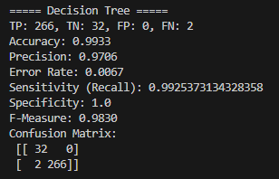
---Naïve Bayes---
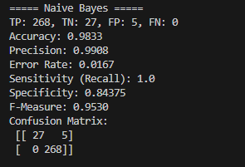
---KNN---
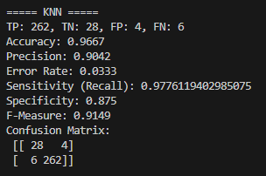

---Classifiers Matrix---
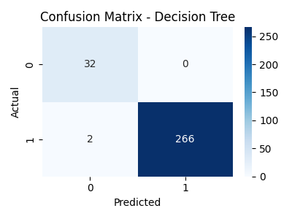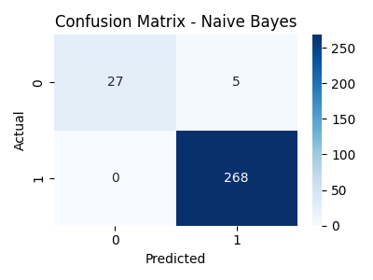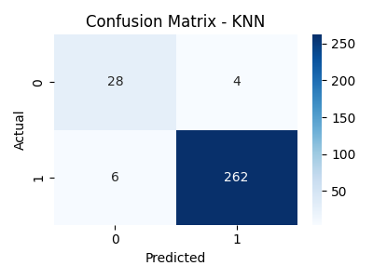
---Combined Matrix---
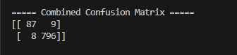
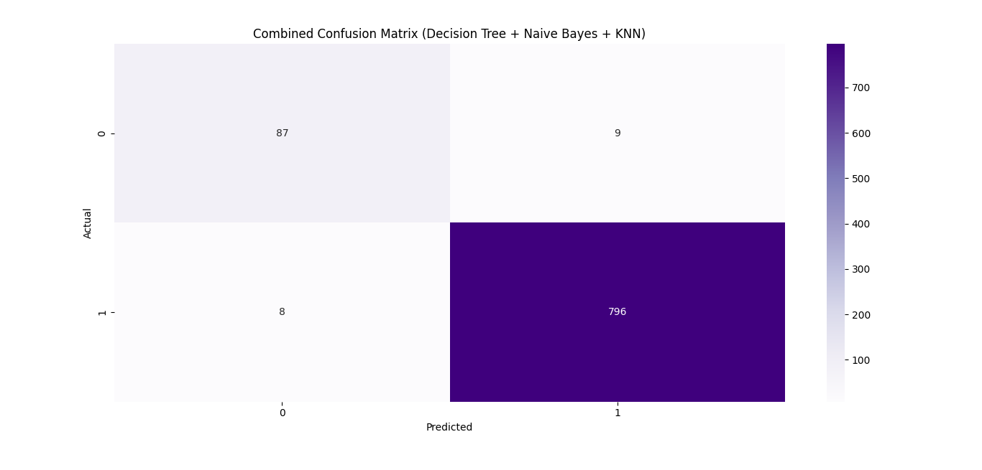
---ROC Curve---
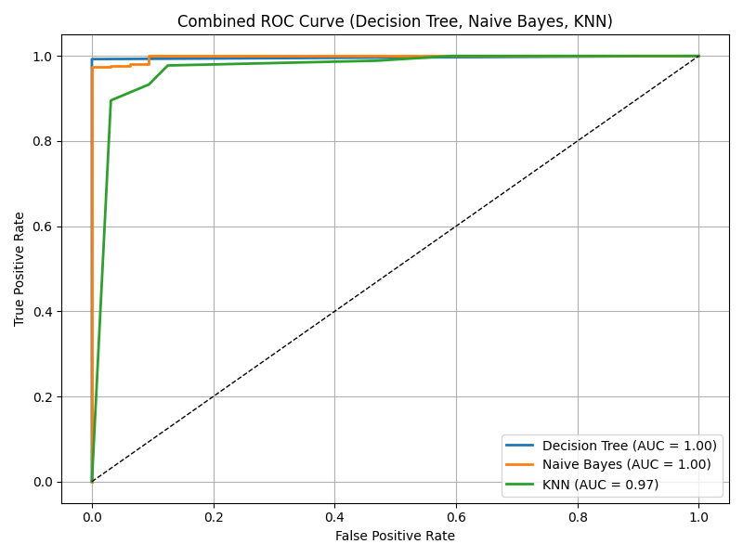
---Summary Table---
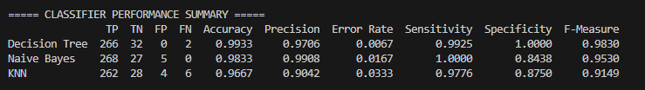
---Best Classifier---


Conclusion:
This project has shown how to effectively pre-process data, train the model, and evaluate performance using multiple machine learning classifiers. Analysing the reduced dataset subset, A–F columns, it could be observed that each algorithm had different strengths with respect to various characteristics of the data. The classifier Decision Tree offered a clear interpretability with high accuracy, whereas Naive Bayes tended to be very efficient with probabilistic reasoning. K-Nearest Neighbour proved reliable for pattern-based prediction, and support vector machines were excellent in complex feature space boundaries. A comparison of metrics like accuracy, precision, recall, specificity, and F-measure together with the combined ROC plot identified the best classifier that balanced accuracy and robustness. The overall study emphasizes that only proper pre-processing and comparative studies can help in choosing the most relevant model in predictive data mining tasks.

